GEO-2000 ALTERNATIVE POLICY STUDIES FOR WEST ASIA: WATER RESOURCE MANAGEMENT IN WEST ASIA

This study was carried out by the Arab Centre for the Studies of Arid Zones and Drylands (ACSAD), Republic of Syria, in collaboration with the Arabian Gulf University (AGU), Bahrain, as part of the preparation for UNEP’s GEO-2000 report.

SUMMARY

The high population growth rate in the West Asia region exceeds by far the rate of developing water resources. Consequently, the annual per capita share of water resources is decreasing, and at an increasing rate. This study shows that developing water resources on a business-as-usual basis will leave the region with serious water shortages, in particular in the Arabian Peninsula where the annual water deficit could increase to as much as 67 percent of demand by 2015.

It is clear that current water resources cannot satisfy future demand much past 2005 without alternative policies. Two alternative policies are examined: in the first one, water supplies are increased, and in the other, water supplies are increased and policies altered. The scenarios show that water deficits can be reduced – though not eliminated – especially if emphasis is placed on cutting the wasteful use of water in agriculture, which accounts for the majority of water use in the region, and by shifting current policies away from stressing food self-sufficiency.

CONTENTS

Status of Water Resources in West Asia; Population Growth and Water Demand; Future Water Demand; Water Resources in West Asia: Three Scenarios; An Alternative Strategy for Sustainably Developing Water Resources in West Asia; References; Tables and Charts.

STATUS OF WATER RESOURCES IN WEST ASIA

The 4-million-square-kilometre West Asia region can be divided geographically and ecologically into two sub-regions, the Mashriq and the Arabian Peninsula. The region comprises 12 states with a total population of 85.6 million in 1995. The Mashriq, with a 1995 population of 45.1 million, includes Lebanon, Syria, Jordan, Iraq and the territories of the National Palestinian Authority (NPA). The Arabian Peninsula, with a 1995 population of 40.5 million, includes Bahrain, Kuwait, Oman, Qatar, Saudi Arabia, the United Arab Emirates (UAE) and Yemen.

The great majority of the region (over 72 per cent) has an annual rainfall of less than 100 millimetres; about 18 per cent receives between 100 and 300 millimetres; under 10 per cent receives between 300 and 1 300 millimetres (ACSAD 1997). About 80 per cent of the region is therefore classified as semi-desert or desert land (AOAD 1995), 16 per cent is subject to desertification, and only 10 per cent is suitable for agriculture (2.3 per cent under irrigation and 7.7 per cent under rainfed cultivation).

Estimates of conventional (surface and groundwater) and non-conventional water resources (desalinated water, wastewater and agricultural drainage) in the region as of 1995 are given in Table 1 (Figure 1). Annual rainfall provides around 443 000 million cubic metres (ACSAD 1997), of which 41 per cent falls in the Mashriq and 59 per cent in the Arabian Peninsula. Surface water resources are estimated to be 88 300 million cubic metres in the Mashriq sub-region and 8 310 million cubic metres in the Arabian Peninsula.

Groundwater exists in both sub-regions, including both shallow and deep aquifers. In the Arabian Peninsula, groundwater in the shallow alluvial aquifers, located along the main wadi channels and the floodplains of drainage basins, is the only renewable water resource, with an approximate annual recharge of 5 020 million cubic metres a year. The Mashriq has frequent low- to medium-intensity rainfall of long duration which favours groundwater recharge. Hence the estimated annual recharge is better, at 8 515 million cubic metres a year.

Shallow aquifer reserves are estimated at 130 500 million cubic metres in the Arabian Peninsula; approximately 13 300 million cubic metres is available in the Mashriq. Coastal alluvial aquifers in the Arabian Peninsula are subject to salt water intrusion due to extensive groundwater withdrawal which has caused salinisation of coastal agricultural lands, resulting in the reduction of agricultural production and the complete loss of some arable land. Similarly, in the Mashriq sub-region the discharge of raw and partially treated wastewater from agriculture, industry and municipalities into water courses is a cause of deep concern over its health impacts; it has subjected agricultural land and water resources to severe pollution, and has contaminated shallow aquifers.

The main source of water for the countries of the Arabian Peninsula is non-renewable fossil groundwater stored in sedimentary deep aquifers. These store significant amounts of groundwater that is thousands of years old. Deep groundwater reserves are estimated at 2 175 thousand million cubic metres, with the major portion (1 919 thousand million cubic metres) in Saudi Arabia (Alalawi and Abdulrazzak 1993). However, recharge to all deep aquifers is estimated at a very limited 2 700 million cubic metres per year. The quality of the deep aquifers varies greatly; only in a few areas is it suitable for domestic consumption. Most of the water from these deep aquifers is used for agricultural purposes.

Groundwater resources in West Asia in general, and the Arabian Peninsula in particular, are in a critical condition because the volumes withdrawn far exceed natural recharge rates, resulting in a continuous decline in groundwater levels and a deterioration in water quality caused by the encroachment of sea water into coastal alluvial aquifers and the up-flow of connate waters in inland aquifers. A 1995 comparison between the Arabian Peninsula's annual groundwater recharge (7 200 million cubic metres) and groundwater abstraction rates (23 600 million cubic metres), indicates that the mining of groundwater reserves in the Arabian Peninsula is about 16 400 million cubic metres; by country, groundwater depletion rates (in millions of cubic metres) are: Bahrain – 100; Kuwait – 200; Oman – 240; Qatar – 140; Saudi Arabia – 13 558; UAE – 1 495; and Yemen – 700 (FAO 1997).

In the Mashriq, there is growing evidence of groundwater depletion in many countries, such as Jordan, Syria and the Gaza Strip, where groundwater use has been increasing, largely because of a decrease in surface water availability (MSE/UNDP 1997). In addition, over-irrigation and surface dumping of partially treated wastewater has generated large volumes of contaminated water, increasing the pollution levels of shallow aquifers.

Desalination technology was introduced in the mid-1950s and has developed very rapidly to counteract the shortage in conventional water sources. The majority of the region's desalination plants are found in the Arabian Peninsula; saltwater treatment facilities in the Mashriq are few and of small capacity. The 45 desalination plants operating in the Arabian Peninsula as a whole in 1992 had a total designed capacity of 2 320 million cubic metres, equivalent to 41 per cent of global capacity (Bushnak 1995; Wagnick 1992), and a total 1995 output of some 1 645 million cubic metres (Zubari 1997). The cost of water desalination ranges from US$1/m3 to US$1.5/m3. All desalination plants have some negative effects on the environment since they cause air pollution by emitting oxides and marine pollution from the rejected brine.

Wastewater treatment in the Arabian Peninsula constitutes an increasing water source driven by escalating water consumption in urban areas. Existing sewage treatment facilities, which process primary wastewater and have a processing capability estimated at 921 million cubic metres a year, could handle about 43 per cent of all domestic wastewater. However, the reused treated wastewater, which does not exceed 392 million cubic metres a year, is used mainly for irrigating fodder crops, gardens, highway landscapes and parks (Zubari 1997). The remainder is dumped at disposal areas to infiltrate shallow aquifers, or into the sea. In the Mashriq, wastewater, except in large cities, is discharged into watercourses and only part of it is used for irrigation purposes.

Recycled irrigation water is not used much in the Arabian Peninsula since excess irrigation water infiltrates the lower horizons and ultimately reaches the groundwater table; only in Saudi Arabia, in Al-Hassa Oasis, is about 30 million cubic metres a year of irrigation water reused in agriculture by mixing it with groundwater (Al-Kuwaiti and others 1999). In the Mashriq sub-region only Syria exploits these water sources, with some 1 210 million cubic metres being recycled annually. This source, however, has future potential given proper irrigation practices are applied. Other forms of non-conventional water sources, such as rainwater harvesting, weather modification, etc. are still in the research stage.

POPULATION GROWTH AND WATER DEMAND

Population growth in West Asia is a major issue affecting all sustainable socio-economic development. The estimated population in 1995 was 85.6 million (UNSPD 1997) with an average growth rate of 3.73 per cent for the Arabian Peninsula (Arab Fund 1995) and 3 per cent for the Mashriq countries. Population projections for West Asia over the period 1995–2015 are given in Table 2 (Figure 2).

The total water used for all purposes in the West Asia region in 1995 amounted to 96 065 million cubic metres (29 565 million cubic metres in the Arabian Peninsula and 66 500 million cubic metres in the Mashriq); average per capita water use in the same year was estimated to be 730 cubic metres a year for the Arabian Peninsula sub-region and 1 475 cubic metres a year in the Mashriq (Table 3; Figure 3)).

The high population growth rate in the region exceeds by far the rate of water resource development. Consequently, the annual per capita share of water resources is decreasing, and at an increasing rate. According to the Global Water Assessment, the share per capita in the Arab world has decreased during the last two decades from 2 200 cubic metres a year to 1 100 cubic metres a year.

Five countries of West Asia have a per capita water use of under 500 cubic metres a year, half the benchmark of 1 000 cubic metres a year which indicates chronic water scarcity (WRI/UNEP/UNDP/WB 1996). Only two countries, Iraq and Syria, actually exceed the 1 000 cubic metres a year benchmark; Saudi Arabia and UAE have done so only by mining their groundwater reserves.

The national economy of most countries of West Asia depends on oil and oil-related industries, commerce, light industries, and agriculture, in descending order. Due to the fast increase in population and urbanisation, domestic water and industry needs are escalating at rates with which available water resources cannot keep pace. Furthermore, the adopted policy of food self-sufficiency imposes continual constraints on the allocation of water resources, which would otherwise reduce the share for agriculture in favour of increased domestic and industrial demand. Currently the agricultural sector takes 85 per cent of available water resources in the Arabian Peninsula and 95 per cent in the Mashriq, followed by domestic water use, 14 per cent and 4 per cent respectively, with industry in both sub-regions accounting for less than 2 per cent.

The water stress experienced by the countries of West Asia in 1995 is expressed in Table 4 (Figure 4) as the percentage of available water resources actually used. The index reaches values of over 100 per cent in five of the seven countries of the Arabian Peninsula and critical values in the remaining two. This indicates that these countries have already exhausted their renewable water resources and are now exploiting non-renewable reserves.

In the Mashriq the water stress index looks better, except for Jordan where it is over 100 per cent. However, all countries of this sub-region have critical conflicts concerning shared water resources which remain to be reconciled. Furthermore, not only are per capita water resources below 1 000 cubic metres a year in 9 out of the 12 countries of West Asia, in 7 countries (Bahrain, Jordan, Kuwait, NPA, Saudi Arabia, UAE and Yemen) they are even below 500 cubic metres a year. The overall value of the water stress index for West Asia is 84.4 per cent, which is considered very critical. It is worth mentioning that groundwater reserves were depleted by over 17 000 million cubic metres in 1995.

FUTURE WATER DEMAND

Clearly, policies regarding the development and rational use of water resources throughout the region urgently need reviewing. Projections of the total sectoral water demand in West Asia over the period 1995–2015 (Table 5; Figure 5) are based on the criteria explained in the box below.

Box 1: Assessing Water Demand in West Asia

Country/Territory |  | 1995 |  | 2000 |  | 2005 |  | 2010 |  | 2015
A. Domestic Water Demand (litres per capita per day)
Bahrain, Kuwait, Qatar, UAE |  | 540 |  | 555 |  | 570 |  | 585 |  | 600
Saudi Arabia, Lebanon |  | 356 |  | 370 |  | 375 |  | 380 |  | 390
Iraq |  | 160 |  | 170 |  | 180 |  | 190 |  | 200
Jordan, Syria, Oman |  | 130 |  | 135 |  | 140 |  | 145 |  | 150
West Bank & Gaza Strip, Yemen |  | 90 |  | 95 |  | 100 |  | 105 |  | 115
B. Industrial Water Demand (litres per capita per day)
Iraq |  | 50 |  | 75 |  | 100 |  | 125 |  | 150
Bahrain, Qatar, UAE |  | 95 |  | 100 |  | 105 |  | 110 |  | 115
Lebanon |  | 55 |  | 65 |  | 75 |  | 95 |  | 115
Saudi Arabia, Jordan, Syria |  | 30 |  | 35 |  | 40 |  | 45 |  | 50
Kuwait, Oman, Yemen |  | 15 |  | 20 |  | 25 |  | 30 |  | 40
West Bank & Gaza Strip |  | 5 |  | 10 |  | 15 |  | 20 |  | 25
C. Agricultural Water Demand in 1995 (litres per capita per day)
Arabian Peninsula |  |  |  |  | Mashriq
Bahrain | 792 |  |  |  | Iraq |  | 6 488
Kuwait | 168 |  |  |  | Jordan |  | 554
Oman | 1 428 |  |  |  | Lebanon |  | 683
Qatar | 1 685 |  |  |  | NPA |  | 177
Saudi Arabia | 2 788 |  |  |  | Syria |  | 2 627
UAE | 1 908
Yemen | 598

• The development in water demand for sectoral users (agriculture, domestic and industry) depends on the normal growth rate of the population in West Asian countries which is currently 3–4 per cent. As an alternative, the medium variant scenario (UNST/ESA/SER.A/145) is used. The 1990 population was used as the base year for the projections, which cover the 20-year period 1995–2015.
• The rates of domestic (A) and industrial (B) water consumption are taken from national reports for 1995. The proposed increases in rates of water consumption are based on estimates of the general availability of water resources, the status and trends of urbanisation, predicted rates of industrial development, and anticipated agro-industrial developments and other social development targets.
• Estimated rates of agricultural water demand (C) are based on 1995 national reports. Increases are based on population growth. A gradual reduction of agricultural water demand (at rates from 5 per cent, to 10 per cent, and eventually 17 per cent) is foreseen in the 2000–2015 period due to anticipated improvements in agricultural production research in the fields of genetic engineering and tissue culture, and particularly due to savings in consumptive use.

The increase in water demand across all sectors will be 47 130 million cubic metres by 2015 and it is evident that agriculture will continue to dominate all other uses. Furthermore, from the available water resources in 1995 of 113 759 million cubic metres (96 612 million cubic metres surface water, 13 050 million cubic metres rechargeable groundwater and 4 097 million cubic metres non-conventional water resources (Table 1; Figure 1)), the anticipated water demand in 2015 of 143 195 million cubic metres (Table 5; Figure 5), and the deteriorating water stress index, it is clear that current water resources cannot satisfy future water demand much past 2005 unless positive steps are taken soon to rationalise water demand management, increase and augment supply, and impose realistic controls on use.

The Arabian Peninsula is already suffering from a deficit in water resources. The 1995 total annual water demand of 29 565 million cubic metres is estimated to grow to 47 320 million cubic metres by 2015 whereas the total available water will hardly exceed 15 400 million cubic metres. Under these circumstances it will be difficult to maintain the regional emphasis on food production and the widespread import of foodstuffs will increase by necessity.

Currently the water deficit is partially compensated for by the over-exploitation of shallow and deep fossil aquifers and by the extensive installation of highly expensive desalination plants. The negative impacts include fast depletion of aquifer reserves, possible conflicts arising from differential use of aquifers shared between states, deteriorating water quality and salinisation of agricultural lands. Furthermore, existing wastewater treatment facilities can cope with only 35 per cent of urban and industrial waste. Pollution from inappropriate disposal of untreated wastewater will create health hazards through the contamination of shallow groundwater aquifers.

These issues are all aggravated by a general weakness among the institutions dealing with water affairs. This is due to inadequate technical capabilities and unsatisfactory coordination between concerned water authorities.

The Mashriq sub-region, with nearly ten times the renewable water resources of the Arabian Peninsula, is in a much better situation. Available resources can theoretically sustain the projected use of 95 875 million cubic metres in 2015. However, strict control measures are needed to curb current problems related to over-exploitation, inefficient re-use of wastewater, untreated industrial waste and pollution of shallow aquifers. Institutional capacity building and enforcement of legislation also require attention, as well as the continuing problem of potential conflicts between neighbouring states over the equitable distribution of shared water resources. Table 6 (Figure 6) summarises the problems and critical issues in the water sector of West Asia. These problems are common in countries of both sub-regions, though the intensity of their environmental impact varies according to the geopolitical and socio-economic status of each country.
WATER RESOURCES IN WEST ASIA: THREE SCENARIOS

Introduction
To develop policies which will ensure the sustainable development of water resources in West Asia, three scenarios, each based on different assumptions, were used to study the potential water balance for the period 1995–2015. The results of the three scenarios are shown in Tables 7, 8 and 9 (Figures 7, 8 and 9 resp.). Proposed remedy policies detailing the range of desired actions for implementation are outlined in Table 10.

Scenario 1: Business as Usual

The assumptions on which this scenario is based are that:
• 1997 UN population projections apply;
• no further development of water resources is anticipated;
• total water demand is estimated based on the criteria given in box 1;
• security of water for domestic and industrial use is assumed as a first priority; and
• agricultural productivity per unit of water is assumed to improve, achieving a 17 per cent saving in agricultural water demand by 2015.

Under this scenario, the Arabian Peninsula will suffer from acute water shortages and fail to fulfil the set policy of maximum possible food self-sufficiency. Water balance will remain in deficit throughout the period, with the percentage water demand deficit varying from 47.9 per cent in 1995 to 67.4 per cent in 2015. A total water deficit of some 31 910 million cubic metres in 2015 is foreseen.

The Mashriq sub-region is better off. The water balance will continue on the positive side. However, the percentage of surplus of water in relation to demand will come down from 31.9 per cent in 1995 to a critical 2.5 per cent in 2015.

For West Asia as a whole, this scenario suggests a deficit of 4 110 million cubic metres in 2005, rising to 29 440 million cubic metres in 2015. The percentage ratio between water balance and total demand will swing from +18.4 per cent in 1995 to –20.55 per cent in 2015 (Table 7; Figure 7).

Furthermore, these disturbing conclusions assume that disputes over shared water resources will be settled and agricultural water demand will decrease. This anticipated reduction in agricultural water demand of 17 per cent by 2015 (box 1) will come from agricultural research to maximise agricultural productivity per unit of water and the application of appropriate technologies, including biotechnologies, to achieve this.

Although scenario 1 appears pessimistic, maybe even unrealistic, there are several justifications for its consideration. West Asia is located in an arid region; 80 per cent of its land is classified as desert or semi-desert. Most of the easily exploited or promising water sources have been developed; remaining locations require heavy investment, laborious investigation and intensive research programmes.

The unresolved political conflicts and the disputes and wars that have inflamed the region in the last three decades have drastically affected the region's economy and upset the socio-economic development plans of all member countries. Potential conflicts over shared water resources – which constitute a significant proportion of total resources – require lengthy and difficult negotiation before equitable reconciliation can be attained. The result has been the postponement of many water development schemes.

Scenario 2: Supply Augmentation

The assumptions on which this scenario is based are that:
• the assumptions for population growth, water consumption rates, domestic and industrial water use and policies of food self sufficiency projected in scenario 1 apply;
• intensive research into developing conventional and non-conventional water sources will increase surface and groundwater resources in the Arabian Peninsula and the Mashriq by 100 million cubic metres a year, giving a total increase of 4 000 million cubic metres by 2015 (2 000 million cubic metres for each sub-region);
• desalination capacity will increase to 3 000 million cubic metres a year in the Arabian Peninsula; and
• wastewater recycling will increase to 3 000 million cubic metres a year in the Arabian Peninsula and 2 000 million cubic metres a year in the Mashriq.

Under the supply augmentation scenario, the water deficit in the Arabian Peninsula will be reduced to 26 470 million cubic metres by 2015; the percentage water demand deficit will increase from 47.9 per cent in 1995 to 55.9 per cent in 2015.

In the Mashriq, while there will be no overall deficit in water resources, the percentage ratio between water balance and total demand will decrease from 47.9 per cent in 1995 to 6.5 per cent in 2015.

For West Asia as a whole, there will be a deficit of 9 380 million cubic metres in 2010 reaching 20 240 million cubic metres in 2015. The percentage ratio between water balance and total demand will drop from +18.4 per cent in 1995 to –14.1 per cent in 2015 (Table 8; Figure 8).

Scenario 3: Supply Augmentation and Policy Remedies

The assumptions on which this scenario is based are that:
• the assumptions of scenarios 1 and 2 apply; and
• a further gradual, rational decrease in consumption patterns outlined in scenarios 1 and 2 is achieved by increasing the efficiency of irrigation, reviewing the price of water and improving wastewater management.

Under this scenario, extensive research, investigation, development and reform programmes will be essential to develop the additional water resources foreseen in scenario 2, to effect the optimum rationalisation of water use and to minimise water losses to gain about 11 600 million cubic metres by 2015. This will be achieved by resolving the major snags and problems that impede the efficient use of the limited available water resources (Table 10).

Even with supply augmentation and policy remedies, the Arabian Peninsula will continue to experience an increasing water deficit, from 14 160 million cubic metres in 1995 to 20 870 million cubic metres in 2015. The percentage ratio between water balance and total demand will level off at around –50 per cent.

Under the same scenario, the Mashriq will continue to enjoy a surplus of water resources, varying between 31 850 million cubic metres in 1995 to 12 230 million cubic metres in 2015. Nevertheless, the percentage of water balance to total demand will decrease from 47.9 per cent in 1995 to 13.6 per cent by 2015.

The result of adding policy remedies to the supply augmentation scenario should result, by 2015, in a decrease in total water demand of 6 000 million cubic metres for the Mashriq and 5 600 million cubic metres for the Arabian Peninsula.

For West Asia as a whole, a deficit of 500 million cubic metres in water resources will be experienced in 2010 rising to 8, 640 million cubic metres in 2015. The percentage of water balance to demand will gradually fall to –6.6 per cent in 2015 (Table 9; Figure 9).

It is evident that scenario 3 is preferable and constitutes an appropriate basis for defining an alternative strategy for securing the sustainable development of water resources in West Asia. Even so, it is clear that the Arabian Peninsula will continue to experience a deficit in its water resources if its food security targets are adhered to. Either the sub-region will have to mine some 361 700 million cubic metres of shallow and deep groundwater resources during the projected period, or it will have to significantly increase imports of agricultural produce to cover the deficit. In the Mashriq, the early equitable settlement of potential conflicts over shared water resources remains a fundamental pressing issue.

AN ALTERNATIVE STRATEGY FOR SUSTAINABLY DEVELOPING WATER RESOURCES IN WEST ASIA

The overall objectives of the following proposed alternative water policies for the countries of West Asia is to secure long-term water supplies while meeting strict criteria for public health requirements and for socio-economic, financial and environmental sustainability. The actions set out below are based primarily on the lessons from scenario 3, and seem to offer the most promising alternatives. They are focused specifically on the acute problems of water supply and management in the West Asia region, and are aimed to encourage:
• the appropriate development of conventional and non-conventional water resources;
• the resolution of conflicts over shared water resources;
• a marked improvement in the efficiency of water use; and
• a substantial decrease in water demand.

Planning and Analysis

Water policy formulation is very data intensive. Reliable data are the basis for the sound planning and implementation of water policy. Comprehensive hydrological data are required to complete a full inventory of the existing quantity and quality of water resources, along with time series for trend analysis and to calculate design parameters for waterworks. Data should be scrutinised to eliminate any exaggeration, and data collection should be well planned and continuous to provide information for assessing the performance of water schemes after implementation and their effect on downstream users.

The scarcity of water resources in West Asia is aggravated by potential conflicts between member countries and their neighbours; these will seriously affect the preparation of future sustainable socio-economic development plans if not reconciled. The development of additional water resources in the region will require well planned, detailed and integrated studies of the potential for surface, groundwater and non-conventional water resources, and cooperation between member states in these studies. Only then can the most appropriate and economically feasible options be selected from among the many recognised techniques, including rainwater harvesting, surface storage, groundwater recharge, wastewater reuse, weather modification, rational exploitation of groundwater aquifers, water importation and desalination of brackish and sea water.

Legal and Institutional Reforms

Water legislation is closely linked with the development of other natural resources, especially in arid regions such as West Asia where environmental conditions are vulnerable and sensitive to deterioration. Water legislation in West Asia is not keeping pace with the demand for water resources and there is an urgent need to critically review all existing legislation and how it relates to the policy options under review. The main areas of legislation that require amendment cover water rights, water abstraction, water quality and environmental standards, water charges, water pollution and environment protection, groundwater protection from depletion and contamination, wastewater treatment and solid waste disposal.

Amended legislation itself will not be effective in implementing new policy without a significant reorganisation of water administrations, and especially the decentralisation of the power and influence of the central governmental bodies responsible for water resource development and management. Indeed, institutional weakness constitutes a major constraint on the management of water resources in most of the countries of West Asia. This is a direct consequence of the institutions dealing with water research having ill-defined responsibilities regarding investigation and studies, planning and management, and the absence of updated powerful legislation to enforce coordination and collaboration between different authorities at local, regional and national levels. Cross-sectoral coordination between the water, agriculture, housing, industry, and planning directorates of governments is also required for efficient and successful policy formulation. Capacity building among the technical staff of research institutes and other water and agricultural administrations is also badly needed.

Economic Considerations

There are strong links between national economies and water resource management. National development strategies – for example strategies for food self-sufficiency – directly influence water allocation and use, while policies to promote exports and foreign exchange earnings from highly priced cash crops call for increased investment in irrigation schemes.

The implementation of effective and efficient policies governing water resources is greatly hindered by the shortage of financial resources. Future sustainable water policies must have positive impacts on central government finances from new tax revenues, prices and charges, and the reduction of subsidies.

Economic incentives could provide effective instruments for rationalising water use provided they do not act against other key economic factors. Possible incentives include water tariffs for domestic and industrial water supplies, charges for abstraction, irrigation, water wastage and pollution, and soft loans for modernising equipment. While the best way of discouraging industrial water pollution may be by setting economic charges for water polluters with pollution charges proportional to the volume and the quality of effluent, implementation difficulties may be encountered through lack of enforcement procedures. The same caveat also applies for irrigation charges, based on metering consumption, area irrigated, type of crop, or length of irrigation time.

Groundwater pricing can be based either on quantity-based charges or on transferable pumping entitlements. Existing problems with monitoring and enforcement suggest that a quantity-based approach is both economically and administratively efficient (FAO 1993) even though it may not be the most effective alternative.

Water Conservation

Records and studies indicate that water is used excessively and wastefully in all sectors – agricultural, domestic and industrial – throughout West Asia. Huge water losses of at least 45 per cent in agriculture arise from inefficient irrigation systems, there is a 20 per cent leakage rate from water supply networks, and 10 per cent losses are recorded for industrial use. All countries of West Asia must incorporate conservation programmes into their water resource management plans to cut down water losses.

In the agricultural sector this can be approached by:
• Reviewing the economics of irrigation and agricultural production and reappraising agricultural policies.
• Improving the efficiency of traditional irrigation systems, introducing appropriate modern irrigation technology and promoting water conservation techniques among farmers and other water users.
• Reviewing current irrigation incentives and tariffs, implementing the necessary legislation to enforce and update regulations on water use and strictly enforcing regulations.
• Improving extension services and programmes for raising awareness among farmers and the public about the economic value of water as a precious, scarce and viable resource.
• Providing subsidies or soft loans to encourage the application of modern irrigation systems.

The domestic and industrial sectors may require:
• Restructured water pricing to reflect the true costs, including environmental costs, of maintaining and operating water supply works and desalination and wastewater treatment plants. Water tariffs in most countries of the Arabian Peninsula are too low to encourage rational water use.
• A review of water pricing mechanisms and the application of escalating tariffs for increasing water consumption.
• The installation of modern water saving technology for distribution systems and households.
• Improved leakage detection in water supply networks.
• Modified building codes to promote efficient use of wastewater for landscaping.
• The application of heavy pollution charges against industrial units violating regulations.
• The obligation for industrial units to treat water before discharging it into watercourses, lakes and other water bodies, and the sea.

Projects and Programs

Water projects and programmes represent the final outcome of the process of water policy review. They constitute a component of the action plan which should be consistent with overall water strategies. During detailed feasibility studies, any proposed projects and programmes must undergo comprehensive review and assessment before implementation, including cost-benefit analysis, cost-effectiveness analysis, environmental impact assessment and economic and financial analysis.

It is suggested that each country of West Asia appoint a national council, if not yet existing, whose members are ministers responsible for water resource development, management and utilisation, to coordinate at the highest political level and formulate the overall water policy of the country. A technical body (secretariat/committee), to be suggested by the council and composed of senior scientists, economists, engineers, lawyers from concerned ministries and authorities, university and research institutes, and public agencies and stakeholders, including (if the country's political system permits) representatives of water users, would help the council and ensure fair institutional and inter-ministerial coordination at the national level.

Any water strategy should consider water sector development, demand, protection and sustainable use in the medium and long term (15–30 years). A lot of data and information are needed to adequately form the base on which the strategy would be formulated, with possible suitable options. The work plan would include several stages, with a number of parameters relevant to each stage. These are:
• The collection and review of existing data and information.
• The review and evaluation of previous development studies.
• The review of current conditions of water resources, population growth, socio-economic conditions, land use, water utilisation, and related legislation in force.
• The evaluation of the potential of water resources.
• Forecasting water demand.
• A water resources development planning framework.
• The assessment of water resources management, institutional reform and water facilities.
• Rough estimates of total cost.
• The evaluation of strategy formulation: financial, economic and social analyses.
According to the evaluation result, the selected options and alternatives for strategy formulation could be decided and programmes, water projects, tariffs, new technologies and legal institutional reform could be recommended.

Water policies are usually projected over long periods and normally have unforeseen impacts which are difficult to measure in detail. They may not be implemented as proposed, instead responding to current needs and priorities. Water policies may require continuous monitoring for progress, re-evaluation or even revision of priorities to meet obstacles. Therefore, monitoring policy actions would benefit policy management.

Conclusion

The successful implementation of these policies is the key to coping with water scarcity in the region. However, failure to achieve the set targets of decreasing agricultural water demand will result in the deterioration of both the quantity and quality of water supplies, widening food deficits, inflaming social unrest, and exacerbating possible regional conflicts. Furthermore, the assumptions built into the other scenarios will delay these problems, not solve them, unless stringent regulatory measures are put into force and policy shifts strictly implemented.

REFERENCES

ACSAD (1996). National Arabic Strategies in Water Resources in the 21st Century. ACSAD/WS/R/89, Damascus, Syria

ACSAD (1997). Water Resources and their Utilisation in the Arab World. 2nd Water Resources Seminar March 8–10, Kuwait

Alalawi and Abdulrazzak, M. (1993). Water in the Arabian Peninsula: Problems and Perspectives. Water in the Arab World: Perspectives and Prognoses. Division of Applied Sciences, Harvard University, Cambridge, United States

Al-Murad, M. A. (1994). Evaluation of Kuwait Aquifer System and Assessment of Future Well Fields Abstraction Using a Numerical 3D Flow Model. M.Sc. Thesis. Arabian Gulf University, Bahrain

Al-Qasimi, H. A. (1997). Management of Wastewater in Qatar. Regional Workshop on Technologies of Wastewater Treatment and Re-use. 2–4 June 1997, Bahrain

Al-Kuwaiti,K.A., Al-Dhofar, M.S. and Al-Jughaiman,A.R. (1999). Efforts on Raising Irrigation Water
Use Efficiency in Al-Hassa Region, Saudi Arabia. Proceedings of the Fourth Gulf Water Conference, 13-17 January, Bahrain, Gulf Water Science and Technology Association

AOAD (1995). Water Use Policies in Arab Agriculture. AOAD/95/RG, Khartoum, Sudan

Arab Fund (1995). The Economic Arabic Report, September, 1995

Bushnak, A.A. (1995). Desalination Technology and Economics. MEC Conference: Putting a price on water, 16-19 January, Bahrain

Durabi, A. A. (1995). Water Resources Management in UAE. The Sixth Regional Meeting of Arab IHP Committees, 25–30 December 1995, Amman, Jordan

FAO (1993). The State of Food and Agriculture, 1993. FAO, Rome, Italy

FAO (1997). Irrigation in the Near East in Figures. Water Report No. 9. FAO, Rome, Italy

GCC (1996). Economic Report No. 11. GCC, General Secretariat, Riyadh, Saudi Arabia

MSE/UNDP. (1997). Country Study: the State of Environment in Syria (Draft). Syrian Ministry of Environmental Affairs, Syria

UNSPD (1997). World Urbanization Prospects: The 1996 Revision (Annex Tables). United Nations Secretariat, Population Division, New York, United States

Wagnick, K. (1992). IDA Worldwide Desalting Plants Inventory. Report No.12, International Desalination Association

WRI/UNEP/UNDP/WB (1996). World Resources 1996–1997. WRI/UNEP/UNDP/World Bank, Oxford University Press, New York, United States, and London, United Kingdom

Zubari, W. K. (1997). Towards the Establishment of a Total Water Cycle Management and Re-use Program in the GCC Countries. 7th Regional Meeting of Arab IHP Committees, 8–12 September 1997, Rabat, Morocco
Table 1: Available Water Resources in West Asia 1995(1)

Country | Conventional Water Resources(2) |  |  |  |  |  | Non-conventional Water Resources
 | SW | GR(3) | GRC |  | GU |  | DS | WW | AD | Total
Arabian Peninsula sub-region
Bahrain | – | – | – |  | 239 |  | 56 | 55 | 0 | 111
Kuwait | – | – | – |  | 255 |  | 240 | 103 | 0 | 343
Oman | 1 450 | 10 500 | 955 |  | 1 223 |  | 34 | 26 | 0 | 60
Qatar | – | 2 500 | 50 |  | 286 |  | 126 | 103 | 0 | 229
Saudi Arabia | 3 210 | 84 000 | 2 340 |  | 17 000 |  | 795 | 526 | 0 | 1 321
UAE | 150 | 20 000 | 125 |  | 1 615 |  | 385 | 102 | 0 | 487
Yemen | 3 500 | 13 500 | 1 550 |  | 2 930 |  | 9 | 6 | 0 | 15
Sub-total | (4)8 310 | 130 500 | 5 020 |  | 23 548 |  | 1 645 | (5)921 | 0 | 2 566
Mashriq sub-region
Iraq | (6)60 000 | NA (7) | 2 000 |  | NA |  | 77 | NA | 0 | 77
Jordan | 692 | 12 000 | 275 |  | 418 |  | 3 | 58 | 0 | 61
Lebanon | 4 800 | 1 300 | 3 000 |  | 200 |  | 2 | 2 | 0 | 4
NPA(8) | 710 | NA | 340 |  | 200 |  | 0 | 0 | 0 | 0
Syria | 22 100 | NA | 2 900 |  | 7 780 |  | 2 | 177 | 1 210 | 1 389
Sub-total | 88 302 | 13 300 | 8 515 |  | 8 598 |  | 84 | 237 | 1 210 | 1 531
Regional total | 96 612 | 143 800 | 13 535 |  | 32 146 |  | 1 729 | 1158 | 1 210 | 4 097

¹ Volumes in multiples of a million cubic metres (Mm3)
² SW: Surface water; GR: Groundwater reserve; GRC: Groundwater recharge; GU: Groundwater used; DS: Desalinated water; WW: Wastewater; AD: Agricultural drainage
³ Groundwater reserves are rough estimates that need thorough verification
⁴ Mostly seasonal flow of wadi systems
⁵ Represents the capacity of wastewater treatment facilities; only 392 Mm3 is reused for irrigation, the remains are used for recharge purposes
⁶ Figures are subject of conflict between Turkey, Syria and Iraq (not yet reconciled)
⁷ No data available
⁸ National Palestinian Authority

(GCC 1996, FAO 1997, Zubari 1997, Al-Qasimi 1997, Durabi 1995, Al-Murad 1994, Alalawi and Abdulrazzak 1992, and official Country Reports)
Table 2: Projection of Population in West Asia(1)

Country | Projection Period |  |  |  |  |  | Percentage Ratio
 | 1995 | 2000 | 2005 |  | 2010 | 2015 | 2015/1995
Arabian Peninsula sub-region
Bahrain | 557 | 618 | 671 |  | 717 | 766 | 138
Kuwait | 1 691 | 1 966 | 2 192 |  | 2 390 | 2 576 | 152
Oman | 2 207 | 2 717 | 3 302 |  | 3 986 | 4 752 | 215
Qatar | 548 | 599 | 648 |  | 693 | 734 | 134
Saudi Arabia | 18 255 | 21 661 | 25 255 |  | 29 222 | 33 483 | 183
UAE | 2 210 | 2 444 | 2 660 |  | 2 869 | 3 049 | 138
Yemen | 15 027 | 18 118 | 21 577 |  | 25 452 | 29 781 | 198
Sub-total | 40 495 | 48 123 | 56 305 |  | 65 329 | 75 141 | 186
Mashriq Sub-region
Iraq | 20 095 | 23 109 | 26 668 |  | 30 422 | 34 248 | 170
Jordan | 5 377 | 6 330 | 7 371 |  | 8 458 | 9 579 | 178
Lebanon | 3 009 | 3 289 | 3 535 |  | 3 742 | 3 961 | 132
NPA(2) | 2 400 | 2 955 | 3 598 |  | 4 362 | 5 286 | 220
Syria | 14 203 | 16 126 | 18 237 |  | 20 468 | 22 652 | 159
Sub-total | 45 084 | 51 809 | 59 409 |  | 67 452 | 75 724 | 168
Regional total | 85 579 | 99 932 | 115 714 |  | 132 781 | 150 865 | 176

¹ Population in multiples of a thousand
² National Palestinian Authority

(UNSPD 1997)
Table 3: Water Use in West Asia (1995)(1)

Country | Domestic | Industry | Agriculture | Total | Water Use(2) | Population(3)
Arabian Peninsula sub-region
Bahrain | 107 | 19 | 161 | 287 | 515 | 557
Kuwait | 297 | 13 | 323 | 633 | 374 | 1 691
Oman | 85 | 6 | 1 150 | 1 241 | 562 | 2 207
Qatar | 85 | 17 | 337 | 439 | 801 | 548
Saudi Arabia | 2 387 | 193 | 18 575 | 21 155 | 1 159 | 18 255
UAE | 600 | 73 | 1 539 | 2 212 | 1 001 | 2 210
Yemen | 470 | 69 | 3 280 | 3 819 | 254 | 15 027
Sub-total | 4 031 | 390 | 25 365 | 29 786 | 4 666 | 40 495
Water use rate(5) | 273 | 26 | 1 701 | 2 000
% of water use | 13.7 | 1.3 | 85 | 100
Mashriq sub-region
Iraq | 1 179 | 344 | 47 584 | 49 107 | 2 444 | 20 095
Jordan | 245 | 50 | 1 088 | 1 383 | 257 | 5 377
Lebanon | 415 | 60 | 750 | 1 225 | 407 | 3 009
NPA(4) | 64 | 0 | 155 | 219 | 91 | 2 400
Syria | 773 | 175 | 13 618 | 14 566 | 1 026 | 14 203
Sub-total | 2 676 | 629 | 63 195 | 66 500 | 4 225 | 45 084
Water use rate(5) | 163 | 38 | 3 840 | 4 041
% of water use | 4 | 1 | 95 | 100
Regional total | 6 707 | 1 019 | 88 560 | 96 286 | 8 891 | 85 579
Water use rate(5) | 215 | 32 | 2 828 | 3 075
% of water use | 7 | 1 | 92 | 100

¹ Volume in multiples of a million cubic metres
² Cubic metres a year
³ Population by thousands
⁴ National Palestinian Authority
⁵ Water use in litres a day per capita

(Data from verified Country Reports, GCC 1996, UNSPD 1997)
Table 4: Water Stress in West Asia (1995)

Country |  | Population 1995  (1 000s) |  | Available Water Resource (1) |  |  | Exploited Water Resource(1) |  | Per capita Water Resource(2) |  | Water  Stress Index (%)
Arabian Peninsula sub-region
Bahrain | 557 |  | 0.111 |  |  | 0.287 |  | 199 |  | >100
Kuwait | 1 691 |  | 0.343 |  |  | 0.538 |  | 203 |  | >100
Oman | 2 207 |  | 2.467 |  |  | 1.241 |  | 1118 |  | 50.3
Qatar | 548 |  | 0.279 |  |  | 0.439 |  | 509 |  | >100
Saudi Arabia | 18 255 |  | 6.871 |  |  | 21.155 |  | 376 |  | >100
UAE | 2 210 |  | 0.762 |  |  | 2.212 |  | 345 |  | >100
Yemen | 15 027 |  | 5.065 |  |  | 3.819 |  | 337 |  | 75.2
Sub-total | 40 495 |  | 15.898 |  |  | 29 691 |  | 393 |  | >100
Mashriq sub-region
Iraq | 20 095 |  | (3)62.077 |  |  | 49.107 |  | 3 089 |  | 79.1
Jordan | 5 377 |  | 1.028 |  |  | 1.383 |  | 191 |  | >100
Lebanon | 3 009 |  | 7.804 |  |  | 1.225 |  | 2 594 |  | 15.7
NPA(4) | 2 400 |  | (3)1.050 |  |  | 0.219 |  | 438 |  | 20.8
Syria | 14 203 |  | (3)26.389 |  |  | 14.566 |  | 1 858 |  | 55.2
Sub-total | 45 084 |  | 98.348 |  |  | 66 500 |  | 2 181 |  | 67.5
Regional total | 85 579 |  | 114.246 |  |  | 96.191 |  | 1 335 |  | 84.3

¹ Volume in multiples of a thousand million cubic metres
² Cubic metres a year
³ Shared water resources of Iraq, NPA, and Syria are subject to reconciliation with neighbouring countries
⁴ National Palestinian Authority

(Data from verified Country Reports, UNSPD 1997)
Table 5: Total Water Demand for West Asia(1)

Country | Projection Period
 | 1995 | 2000 | 2005 |  | 2010 | 2015
Arabian Peninsula sub-region
Agriculture | 25 146 | 28 293 | 31 237 |  | 34 525 | 38 180
Domestic | 4 029 | 4 902 | 5 772 |  | 6 738 | 7 912
Industry | 390 | 545 | 729 |  | 954 | 1 228
Sub-total | 29 565 | 33 740 | 37 738 |  | 42 217 | 47 320
Mashriq sub-region
Agriculture | 63 195 | 68 851 | 74 884 |  | 81 347 | 88 049
Domestic | 2 676 | 3 195 | 3 794 |  | 4 456 | 5 171
Industry | 629 | 995 | 1 448 |  | 2 006 | 2 655
Sub-total | 66 500 | 73 041 | 80 126 |  | 87 809 | 95 875
West Asia region
Agriculture | 88 341 | 97 144 | 106 121 |  | 115 872 | 126 228
Domestic | 6 705 | 8 097 | 9 566 |  | 11 194 | 13 084
Industry | 1 019 | 1 540 | 2 177 |  | 2 960 | 3 883
Regional total | 96 065 | 106 781 | 117 864 |  | 130 026 | 143 195

¹ Volume in multiples of a million cubic metres
(Figures based on criteria explained in Table 6, ACSAD 1997, UNSPD 1997)

Table 6: Water Sector Problems and Critical Issues in West Asia

Problem | Evidence | Causes | Importance
• Limited water resources. | • Depletion of available water per capita over time. | • Arid region with frequent drought cycles.  • Growing population.  • Food self-sufficiency policies. | • Socioeconomic development slows down.
• Disputes over shared water resources. | • Decrease of surface flow at border.  • Remarkable lowering of water table at borders.  • Local water resources fully used. | • Reconciliation of conflicts not concluded.  • Failure of planning and forecasting for future development. | • Involves the majority of available water in West Asia.
• Inefficient use of water. | • Irrigation losses up to 45 per cent.  • Excessive leakage from supply networks.  • Wasteful water use. | • Extensive traditional irrigation practice.  • Old water supply networks.  • Lack of awareness.  • Lack of realistic pricing.  • Lack of stringent regulation. | • Excessive losses of available water.
• Internal water allocation conflicts. | • Increasing competition among sectoral users. | • Growing water demand.  • Limited water resources. | • Increasing water scarcity.
• Deteriorating water quality. . | • Contamination of surface water.  • Sea water intrusion.  • Groundwater depletion.  • Loss of agricultural lands. | • Discharge of untreated domestic and industrial effluent into water courses.  • Over-exploitation of groundwater.  • Lack of strict penalties.  • Irrational water demand.  • Insufficient studies. | • Water-related diseases.  • Soil damage.  • Complicated groundwater problems.  • Negative impact on environment.
• Inferior quality of water services. | • Lack of sewage systems in large areas.  • Water-related diseases.  • Groundwater pollution. | • Shortage of financing.  • Growing population.  • Fast pace of urbanisation. | • Influence on development and welfare.
• Weak institutions. | • Duplication of efforts.  • Inefficient water management. | • Ill-defined responsibilities.  • Lack of coordination.  • Inadequate technical capacity and training. | • Poor water development.  • Inefficient services.
Table 7: Water Balance in West Asia(1)
Scenario I: Business As Usual

Assumptions:
• No development of new water sources after 1995 is foreseen.
• UN projection of population (1997) is applied.
• Water demand for domestic and industry is secured.
• Rates for water consumption as shown in box 1.
• Improved agricultural productivity will achieve 17 per cent saving in agricultural water demand by 2015 (see box 1).
• Shared water resource disputes are settled.

 | 1995 | 2000 |  | 2005 | 2010 | 2015
Arabian Peninsula sub-region
Available water resources | 15.41 | 15.41 |  | 15.41 | 15.41 | 15.41
Total water demand | 29.57 | 33.74 |  | 37.74 | 42.22 | 47.32
Water balance | –14.16 | –18.33 |  | –22.33 | –26.81 | –31.91
% W. balance/demand | –47.90 | –54.30 |  | –59.20 | –63.50 | –67.40
Mashriq sub-region
Available water resources | 98.35 | 98.35 |  | 98.35 | 98.35 | 98.35
Total water demand | 66.50 | 73.04 |  | 80.13 | 87.81 | 95.88
Water balance | 31.85 | 25.31 |  | 18.22 | 10.54 | 2.47
% W. balance/demand | 47.90 | 34.70 |  | 22.70 | 12.00 | 2.60
West Asia region
Available water resources | 113.76 | 113.76 |  | 113.76 | 113.76 | 113.76
Total water demand | 96.07 | 106.78 |  | 117.87 | 130.03 | 143.20
Water balance | 17.69 | 6.98 |  | –4.11 | –16.27 | –29.44
% W. balance/demand | 18.40 | 6.50 |  | –3.50 | –12.50 | –20.55

¹ Volume in multiples of a thousand million cubic metres

Table 8: Water Balance in West Asia(1)
Scenario II: Supply Augmentation

Assumptions:
• Available water resources are developed as follows:
Groundwater at 100 Mm3 a year, i.e. 2 000 Mm3 for each sub-region by 2015.
Desalination plant capacity is increased gradually to reach 3 000 Mm3 in the Arabian Peninsula by 2015.
Wastewater plant capacity is increased to reach 3 000 Mm3 in the Arabian Peninsula and 2 000 Mm3 in the Mashriq by 2015.
• UN projection of population (1997) is applied.
• Domestic and industrial consumption are secured.
• Rates of water consumption are as shown in box 1.
• Improved agricultural productivity will achieve 17 per cent saving in agricultural water demand by 2015 (see box 1).
• Shared water resource disputes are settled.

 | 1995 | 2000 |  | 2005 | 2010 | 2015
Arabian Peninsula sub-region
Available water resources | 15.41 | 16.74 |  | 18.11 | 19.48 | 20.85
Total water demand | 29.57 | 33.74 |  | 37.74 | 42.22 | 47.32
Water balance | –14.16 | –17.00 |  | –19.63 | –22.74 | –26.47
% W. balance/demand | –47.90 | –50.40 |  | –52.00 | –53.90 | –55.90
Mashriq sub-region
Available water resources | 98.35 | 99.29 |  | 100.23 | 101.17 | 102.11
Total water demand | 66.50 | 73.04 |  | 80.13 | 87.81 | 95.88
Water balance | 31.85 | 26.25 |  | 20.10 | 13.36 | 6.23
% W. balance/demand | 47.90 | 35.90 |  | 25.10 | 15.20 | 6.50
West Asia region
Available water resources | 113.76 | 116.03 |  | 118.34 | 120.65 | 122.96
Total water demand | 96.07 | 106.78 |  | 117.86 | 130.03 | 143.19
Water balance | 17.69 | 9.25 |  | 0.47 | –9.38 | –20.24
% W. balance/demand | 18.40 | 8.70 |  | 0.40 | –7.20 | –14.10

¹ Volume in multiples of a thousand million cubic metres
Table 9: Water Balance in West Asia(1)
Scenario III: Supply Augmentation and policy remedies

Assumptions:
UN projection of population (1997) is applied.
Conventional and non-conventional water resources will develop as in Scenario II.
Rational use of water will result in a gradual saving in water demand, reaching 5 600 Mm3 in the Arabian Peninsula and 6 000 Mm3 in the East Mediterranean by 2015.

 | 1995 | 2000 |  | 2005 | 2010 | 2015
Arabian Peninsula sub-region
Available water resources | 15.41 | 16.74 |  | 18.11 | 19.48 | 20.85
Total water demand | 29.57 | 32.34 |  | 34.94 | 38.02 | 41.72
Water balance | –14.16 | –15.60 |  | –16.83 | –18.54 | –20.87
% W. balance/demand | –47.90 | –48.20 |  | –48.20 | –48.80 | –50.00
Mashriq sub-region
Available water resources | 98.35 | 99.29 |  | 100.23 | 101.17 | 102.11
Total water demand | 66.50 | 71.54 |  | 77.13 | 83.31 | 89.88
Water balance | 31.85 | 27.75 |  | 23.10 | 17.86 | 12.23
% W. balance/demand | 47.90 | 38.80 |  | 29.90 | 21.40 | 13.60
West Asia region
Available water resources | 113.76 | 116.03 |  | 118.34 | 120.65 | 122.96
Total water demand | 96.07 | 103.88 |  | 112.07 | 121.33 | 131.60
Water balance | 17.69 | 12.15 |  | 6.27 | –0.68 | –8.64
% W. balance/demand | 18.40 | 11.70 |  | 5.60 | –0.60 | –6.60

¹ Volume in multiples of a thousand million cubic metres
Table 10: Proposed Policy Matrix for Water Sector in West Asia

Water  policy | Planning  & analysis | Legal  & institutional | Economic  regimes | Projects  & programmes
Prioritise water supply for domestic, industrial, and agricultural use. | Assess water resources.  Project population growth.  Project water demand.  Monitor water quality. | Establish protection zones for surface water and well field water, springs, and catchment areas.  Establish new competent authorities.  Control illicit connections.  Train staff. | Increase water tariffs for high water demand sectors.  Provide funds for M&O and new water facilities.  Provide strict regulation and penalties.  Apply metering systems widely.  View water as an economic commodity.  Encourage full user participation.  Control industrial intake & discharge points. | Study regional hydrology and hydrogeology.  Continuously maintain water facilities and networks.  Construct water purification and desalination plants for future needs.  Change consumer behaviour through information and education.  Improve sanitation.
Settle conflicts over shared water resources. | Negotiate.  Share data and information. | Cooperate regionally and internationally. |  | Monitor the quality and quantity of water flow.
Use water rationally. | Map connections to detect leakage. | Support water saving measures through regulation.  Detect and control illicit connections.  Fully apply metering systems.  Establish adequate institutions and staff training to properly control water use. | Institute proper water pricing.  Check metering systems rotationally.  Reviewing water supply costing. | Treat drainage water.  Apply water saving technologies.  Study rational water use.  Educate consumers to change behaviour.  Calibrate meters regularly.  Detect and control leakage.  Maintain and rehabilitate network regularly.
Protect groundwater reserves. | Comprehensively monitor groundwater quality.  Encourage conjunctive use of surface and groundwater. | Control rate of pumping to prevent mining the reserve.  Promote efficient management by coordinating institutions.  Apply metering systems.  Adopt detailed well drilling licensing.  Enforce stringent penalties for groundwater depletion and contamination. | Change the irrigation charge system to be based on volume of drawn water.  Cancel subsidies for well drilling.  Give appropriate incentives for applying water irrigation technology.  Review water tariffs for domestic and industrial abstraction. | Apply water saving technologies.  Update studies on groundwater availability for sustainable water management.  Implement artificial recharge.  Organise public awareness and educational programmes.
Control water pollution and protect the environment. | Standardise drinking water quality.  Standardise quality of industrial effluents.  Improve water quality monitoring system.  Provide funds for studies. | Train staff in water conservation.  Enforce stringent penalties for drinking water pollution.  Restrict activities in watershed areas and well field zones.  Legislate for treating industrial effluents before discharge into water bodies and water courses.  Establish competent authorities to control water pollution. | Apply the 'polluter pays' principle.  Assess pollution charges in proportion to the volume and quality of effluents. | Expand sewage water processing facilities.  Assess environmental impact of all water projects.  Promote public awareness through education campaigns.  Construct wastewater treatment plants close to large communities and industrial areas.  Improve sewage networks.
Increase the efficiency of water use. | Encourage conjunctive use of surface and groundwater.  Conduct studies on crop consumption of water resources.  Extensively apply water-saving irrigation systems. Continuously monitor the water use of different sectors. | Implement metering systems for different water uses.  License well drilling and water abstraction.  Apply strict regulation to control illegal abstraction.  Encourage user group participation. | Base irrigation charges on volume of water consumed.  Give incentives for modern irrigation.  Instigate a rotational review of irrigation charges.  Increase water supply tariffs for high domestic and industrial water consumers. | Apply water-saving technologies.  Increase efficiency in distribution and irrigation canal systems.  Promote multi-purpose water use.  Employ education campaigns.  Re-use wastewater and drainage water.  Maintain water supply networks regularly.
Build institutional capacity. | Develop human resources and train technical staff.  Enhance the capacity of research institutes and universities.  Apply new technologies for administration and management.  Upgrade monitoring and network equipment.  Implement water resources development and management modeling. | Update legislation to enforce coordination between water administrations.  Define clear responsibilities and duties for water administrations.  Integrate water use management programmes. | Provide financial support for upgrading institutional capability.  Increase civil service efficiency through incentives schemes.  Improve accounting and costing systems.  Improve budget control systems. | Create training programmes to enhance technical and professional skills.  Explore options for privatising services.

Figure 1

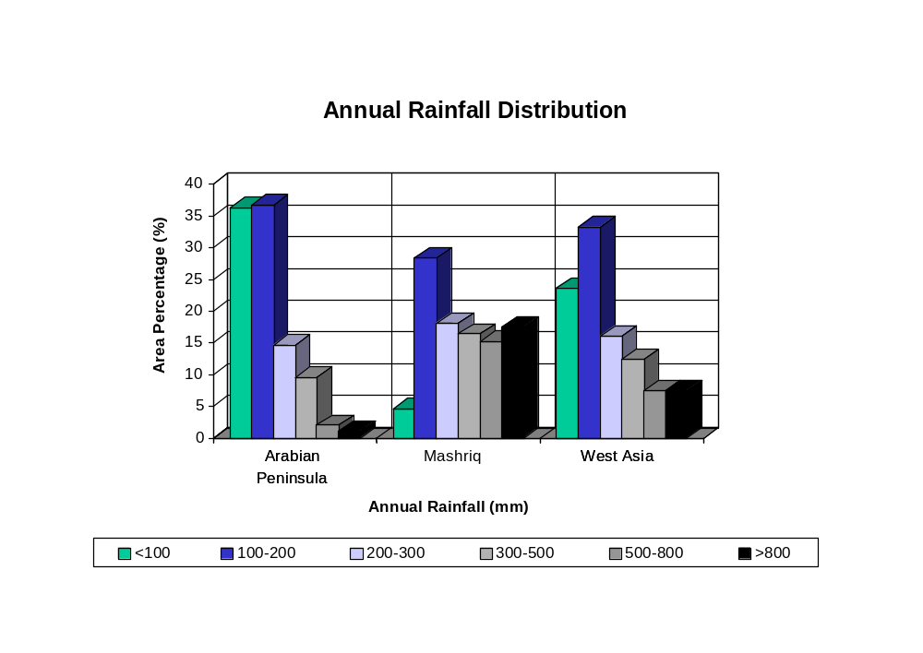

Figure 2

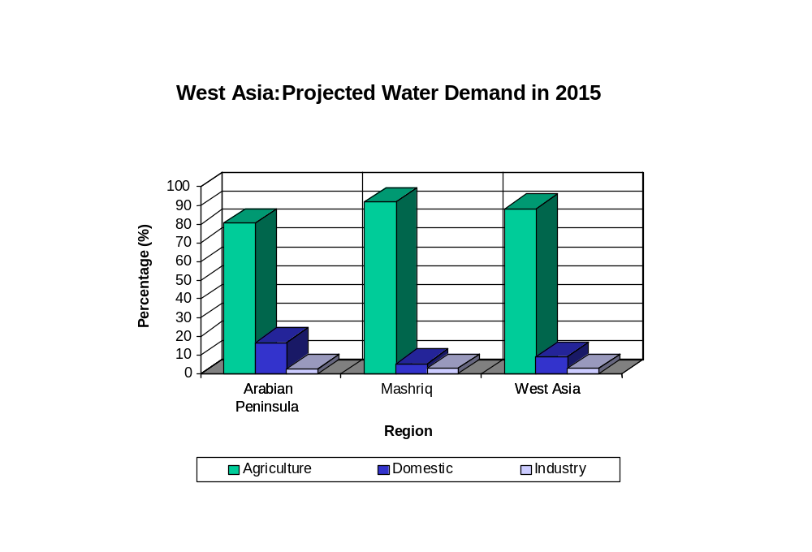

Figure 3

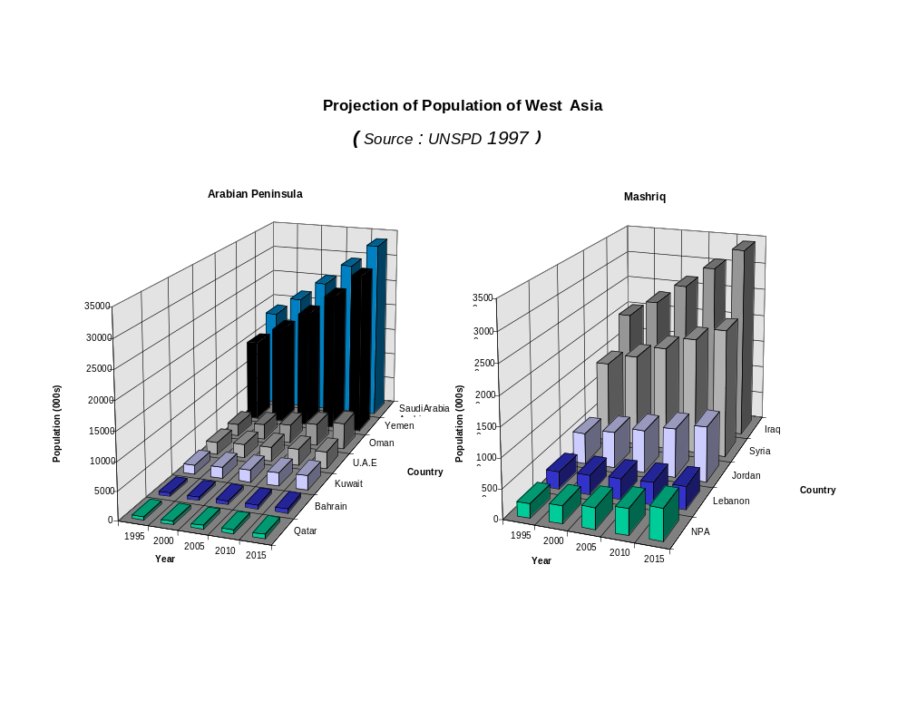

Figure 4

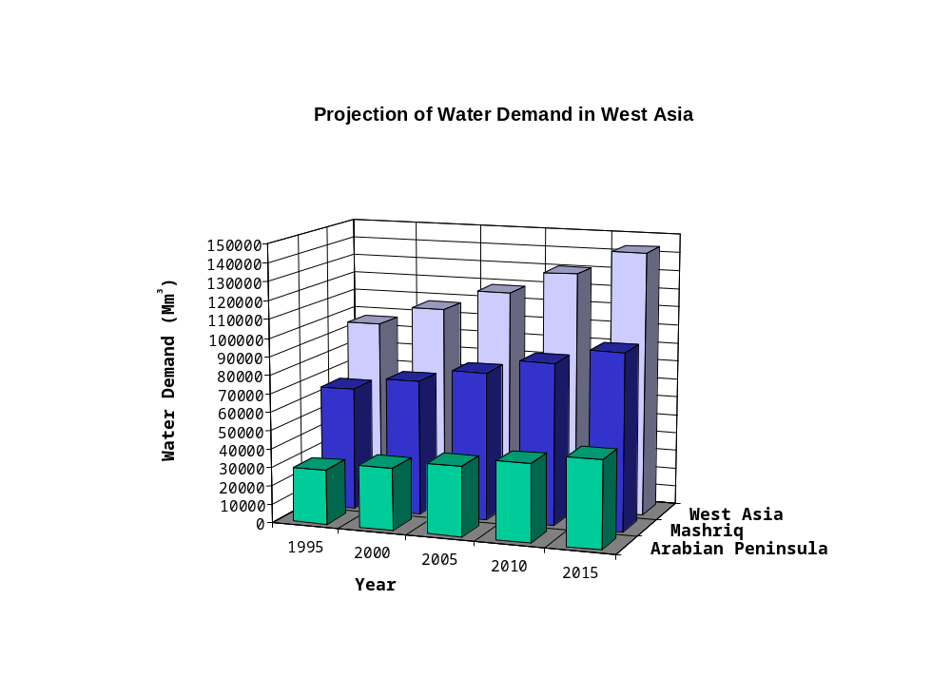

Figure 5

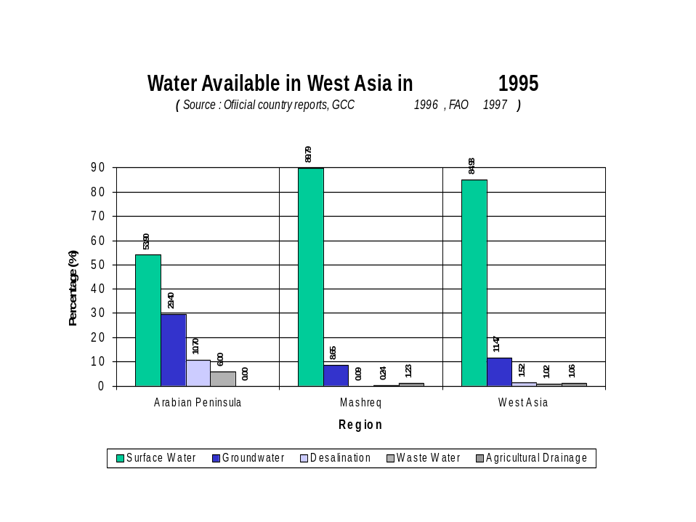
Mashriq

Water Available in West Asia in 1995
(Source: Official country reports, GCC 1996, FAO 1997)
Wastewater

Figure 6

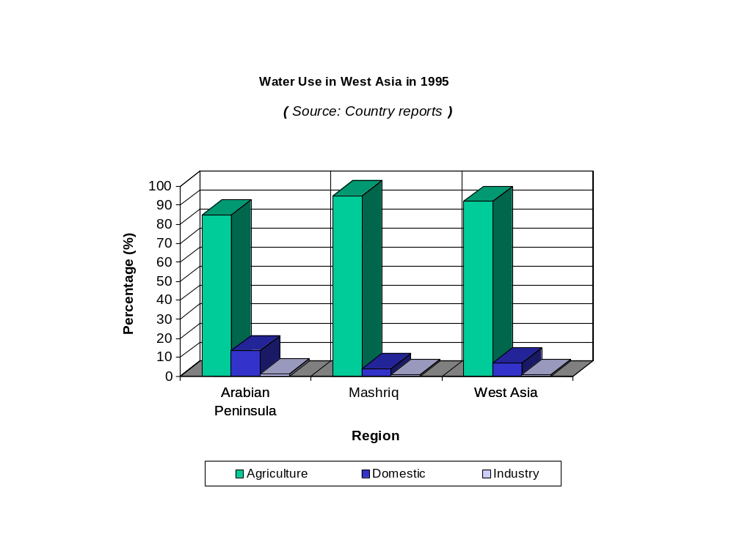

Figure 7

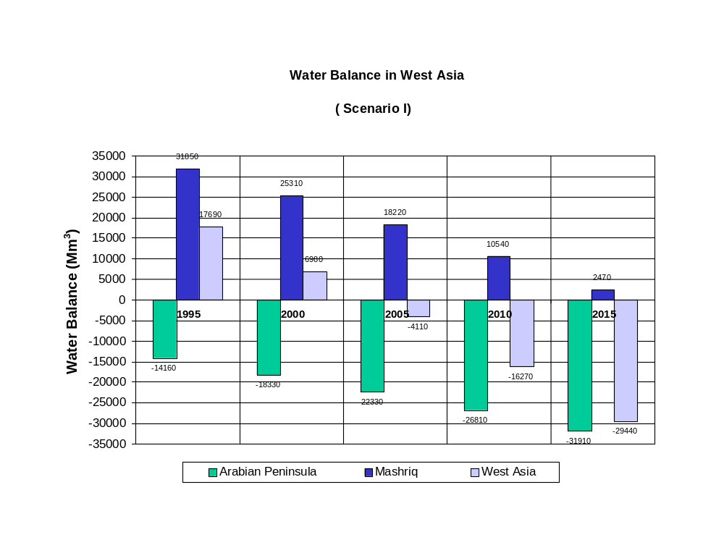

Figure 8

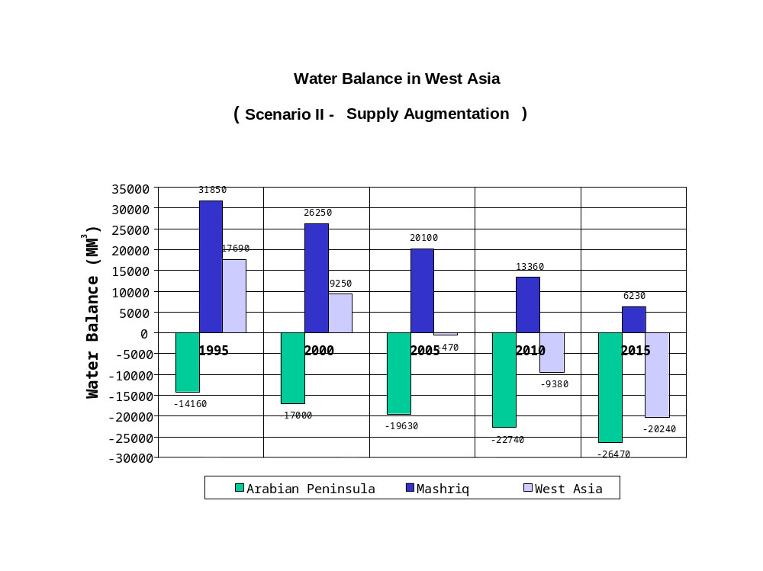

Figure 9

